Home Page

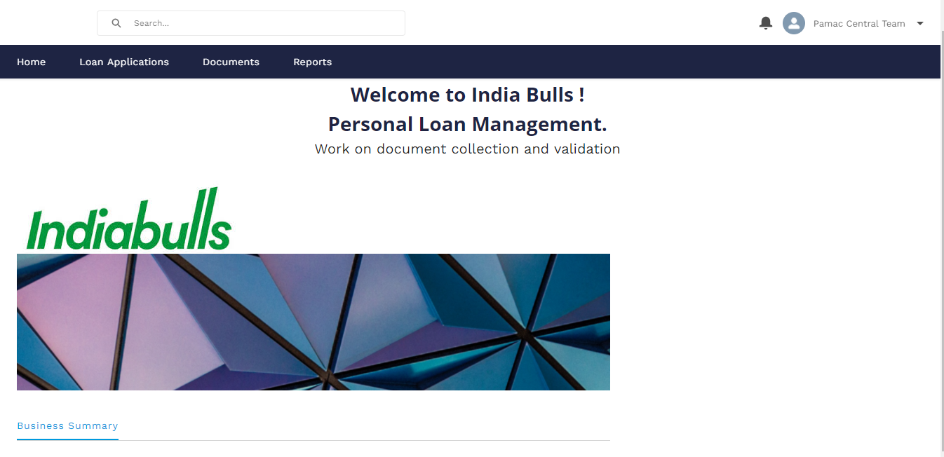

Click on Loan Applications to view the document list

Click on Lead Assigned to view the list of leads assigned to PAMAC/Shellex

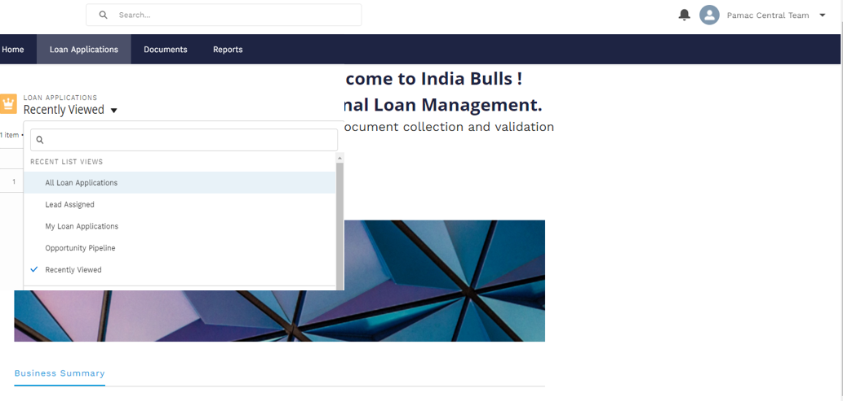

lead assignment report screen  
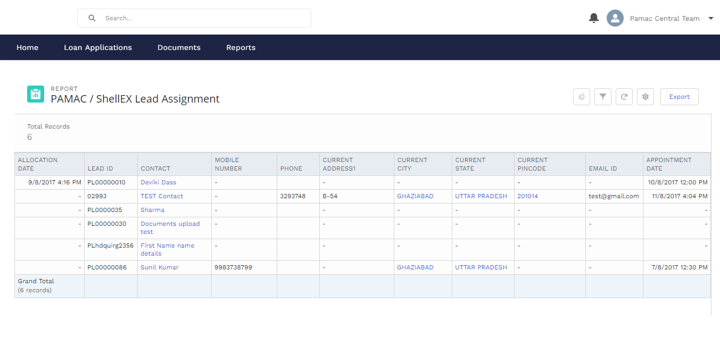

Click on export to download the leads assigned into an excel file

Exported file view

